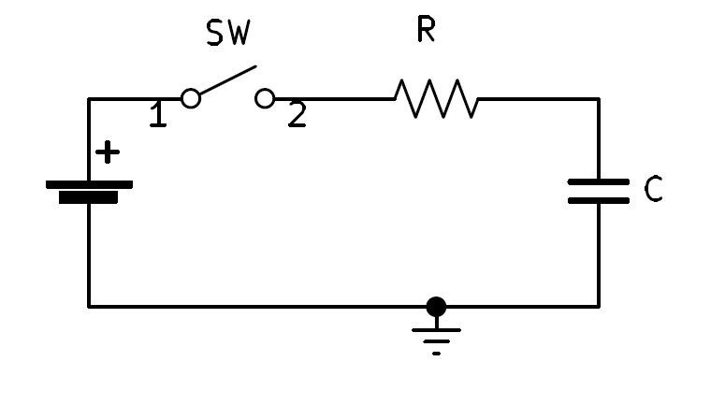After the switch is closed, how long does it take for the capacitor to fully charge?

$VC=VFin -(VFin -Vin)e^{\frac{-t}{RC}}$

* $τ=RC$ (seconds)
* Formula in terms of % and time vs. tau
* time = **1tau**
$VC=100\%VFin -(100\%VFin -0Vin)e^{\frac{-1}{1}}$

$VC=100\%VFin -(100\%VFin)e^{-1}$

$VC=100\%VFin -\left(100\%VFin\right)\left(.36787944\right)$

$VC=100\%VFin -\left(36.787944\%VFin\right)$

$VC=63.212056\%VFin$

* **@ 1tau**, $VC=63.212056\%VFin$
* Formula in terms of % and time vs. tau
* time = **2tau**
$VC=100\%VFin -(100\%VFin -0Vin)e^{\frac{-2}{1}}$

$VC=100\%VFin -(100\%VFin)e^{-2}$

$VC=100\%VFin -\left(100\%VFin\right)\left(.13533528\right)$

$VC=100\%VFin -\left(13.533528\%VFin\right)$

$VC=86.466471\%VFin$

* **@ 2tau**, $VC=86.466471\%VFin$
* Formula in terms of % and time vs. tau
* time = **3tau**
$VC=100\%VFin -(100\%VFin -0Vin)e^{\frac{-3}{1}}$

$VC=100\%VFin -(100\%VFin)e^{-3}$

$VC=100\%VFin -\left(100\%VFin\right)\left(.049787068\right)$

$VC=100\%VFin -\left(4.9787068\%VFin\right)$

$VC=95.02129316\%VFin$

* **@ 3tau**, $VC=95.02129316\%VFin$
* Formula in terms of % and time vs. tau
* time = **4tau**
$VC=100\%VFin -(100\%VFin -0Vin)e^{\frac{-4}{1}}$

$VC=100\%VFin -(100\%VFin)e^{-4}$

$VC=100\%VFin -\left(100\%VFin\right)\left(.018315639\right)$

$VC=100\%VFin -\left(1.8315639\%VFin\right)$

$VC=98.1684361\%VFin$

* **@ 4tau**, $VC=98.1684361\%VFin$
* Formula in terms of % and time vs. tau
* time = **5tau**
$VC=100\%VFin -(100\%VFin -0Vin)e^{\frac{-5}{1}}$

$VC=100\%VFin -(100\%VFin)e^{-5}$

$VC=100\%VFin -\left(100\%VFin\right)\left(.006737947\right)$

$VC=100\%VFin -\left(.6737947\%VFin\right)$

$VC=99.3262\%VFin$

* **@ 5tau**, $VC=99.3262\%VFin$

|  |  |
| --- | --- |
| Tau | Vc % Charge of Vfin |
| 1 | 63.21206% |
| 2 | 86.46647% |
| 3 | 95.02129% |
| 4 | 98.16844% |
| 5 | 99.32621% |